SCHOOL OF EDUCATION AND CHILD DEVELOPMENT

Standard Course Syllabus Template

for Graduate Education Courses (Seated, Blended, or Online)

This document provides faculty teaching education courses with a template for syllabi that includes the information required by the School of Education and Child Development.

- Information in blue and enclosed in [square brackets] should be replaced or deleted before making the syllabus available to students.
- The faculty member may add additional material as deemed appropriate for their course.
- None of the required information (outside the square brackets) in this template should be deleted or modified without express permission from the Dean. If in doubt, please ask.

- Use the current, updated Course Learning Outcomes from the SECD Adjunct Hub on Canvas.

- For current course descriptions and prerequisite lists, consult the current academic calendar: https://www.drury.edu/academics/catalogs

- Use the current, updated Syllabi Statements supplied by the SECD &/or the University.

Submit an electronic copy of your syllabus
two weeks prior to the start of classes each semester to
the School of Education and Child Development:

education@drury.edu

Template updated: July 7, 2023

[Delete this page before publishing your syllabus.]

SCHOOL OF EDUCATION AND CHILD DEVELOPMENT

Graduate Course Syllabus (Seated/Blended/Online)
INSERT Course CODE/TITLE

Drury University Mission:
Drury University is an independent university, church-related in the liberal arts tradition, and committed to personalized education in a community of scholars who value the arts of teaching and learning. Education at Drury seeks to cultivate spiritual sensibilities and imaginative faculties as well as ethical insight and critical thought; to foster the integration of theoretical and practical knowledge; and to liberate persons to participate responsibly in and contribute to a global community.

School of Education and Child Development Mission:
To prepare the best educators for diverse 21st Century learning environments.

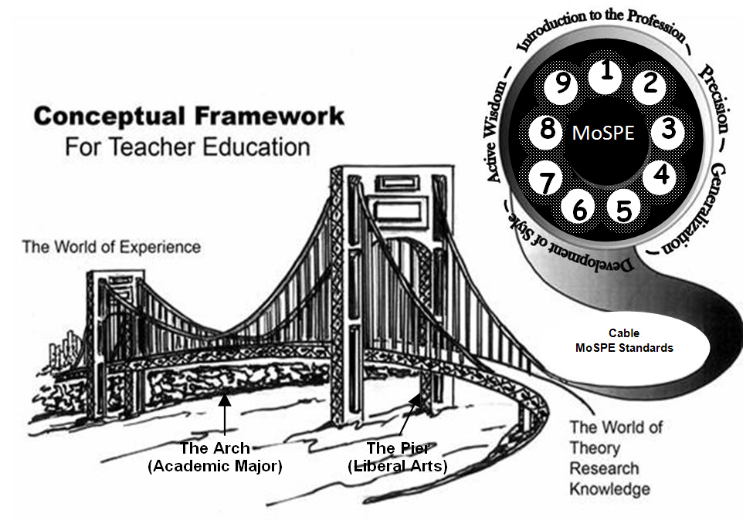

Course Title: |  | [Insert course title – use actual title from academic catalog.]
Course Number: |  | [Insert course number – include course prefix, number, location, section.]
Course Semester: |  | [List semester and year – such as Fall 2018.]
Course Schedule: |  | [List meeting days and times of the course.]
Course Location: |  | [List the campus location, building name and room number.]
Instructor: |  | [Insert your name.]
Contact Information: |  | DU Office Phone:
 |  | DU Email:
 |  | Office Hours:
Availability: |  | [Best times and methods to reach you.]
Instructor’s Bio: |  | [Provide a brief description of your qualifications and professional experience which prepares you to teach this course.]
Course Description: |  | [Insert exact course description from the academic catalog, additional text may be added (separate from the actual description) to provide clarity. Note: If this is a blended course, explain how your blended course will be structured (seated meeting dates/times, etc., beneath the course description) ]
Prerequisite Course(s), if any: |  | [List all courses specified as prerequisites for this course. If none, simply state “None” here. ]
Required Text(s): |  | [List all required texts for the class, including ISBN, author, publisher, and edition.]
Electronic Resources: |  | [List all electronic resources and web sites for course.]  Seated Course: This course is being offered as a fully seated course. Your instructor may use Canvas for learning activities that supplement class meetings, so please be prepared to access Canvas (http://drury.instructure.com). Your syllabus and grades will be kept in Canvas.  Online Course: This course is offered as a 100% online course which utilizes Canvas (http://drury.instructure.com). All course work occurs online; therefore, active participation in the online activities and completion of all homework and online assignments is required in order to pass this course. Please bookmark Canvas so you can access the site directly in case the campus network is down (http://drury.instructure.com).
Important Dates: |  | [List important dates for course such as: holidays, drop dates, mid-term and final exams.] https://www.drury.edu/academic-affairs/academic-calendar
SECD Program Learning Outcomes: |  | - Candidates demonstrate proficiency in the 10 InTASC standards at the appropriate progression level(s) in the following categories: the learner and learning; content; instructional practice; and professional responsibility. (MTS 2; MTS 4; MTS 5)  - Candidates use content-specific research and theory to design, implement, assess, and reflect on student learning. (MTS 1; MTS 7)  - Candidates demonstrate skills and commitment that afford all K‐12 students access to rigorous and relevant curriculum specific to their diverse learning needs. (MTS 3)  - Candidates model and apply technology standards to design, implement, and assess developmentally‐appropriate learning experiences to engage students and improve learning. (MTS 6; MTS 7)  - Candidates demonstrate proficiency in oral and written communication skills appropriate for educators. (MTS 6; MTS 9)  - Candidates meet all institution and state requirements to be recommended for initial certification. (MTS 8; MTS 9)
Course Learning Outcomes: |  | [ Course objectives must be aligned to the Missouri Teacher Standards and InTASC standards - use link for alignment:  https://drive.google.com/file/d/11xHmKaIPRsQWcXSfhPKKs5cBXNESvgni  Align to other relevant standards as appropriate (such as ACEI for elementary, ISTE for technology, CEC for special education, etc - see link below)  http://www.caepnet.org/working-together/member-partners ]
Course Objective | Missouri Teacher Standards |  | InTASC Standards | CAEP Standards | Related Coursework and Assignment(s)
Compare and contrast relevant developmental theories in terms of approach, focus, strengths and limitations. | Standard 2.1: Teacher uses developmental factors and theories to guide instruction  Standard 8.2: Teacher engages in ongoing professional learning |  | Standard 1: Learner Development. The teacher understands how children learn and develop, recognizing that patterns of learning and development vary individually within and across the cognitive, linguistic, social, emotional, and physical areas, and designs and implements developmentally appropriate learning experiences.  Standard 9: The teacher engages in ongoing professional learning and uses evidence to continually evaluate his/her practice, particularly the effects of his/her choices and actions on others (learners, families, other professionals, and the community), and adapts practice to meet the needs of each learner. | Standard 1.0: Development, Learning, and Motivation. Candidates know, understand, and use the major concepts, principles, theories, and research related to development of children and young adolescents to construct learning opportunities that support individual students’ development, acquisition of knowledge, and motivation.  Standard 5.1: Professional growth, reflection and evaluation. Candidates are aware of and reflect on their practice in light of research on teaching, professional ethics, and resources available for professional learning; they continually evaluate the effects of their professional decisions and actions on the learning community and actively seek out opportunities to grow professionally. | Units on developmental theories and the Grand Theories of Psychology.  Feldman pp. 12-24.  Assignment 1.  Assignment 3.
[ Please delete example above from your syllabus ]

[Edit the table to describe the objectives to be covered in the course, as well as products/artifacts.]

Course Objective | Missouri Teacher Standards | InTASC Standards | [Other relevant standard(s)] | Related Coursework and Assignment(s)

Electronic Portfolio: | Maintenance of an electronic portfolio is a requirement for all students in the Drury School of Education and Child Development. This requirement not only serves our national accreditation, but it holds both student and faculty accountable for the quality of the teacher preparation program. Candidates enrolled in any course must maintain a current subscription to [Insert Program] and upload coursework artifacts as directed by faculty. Failure to do so may result in disciplinary consequences, including delayed graduation, until these requirements are fulfilled.

Assignments and Grading: | [Insert your description and schedule of readings, assignments, tests and exams. A sample follows:
 | Week: | Due Date: | Assignment:
 | 1 | 01/17/07 | Read Chapter 1
 | 2 | 01/24/07 | Read Chapter 2
 | 3 | 01/31/07 | Quiz 1 over Chapters 1 and 2; Read Chapter 3
 | 4 | [continues…] | ]
 | [List the required assignments, due dates and point values for the course. A sample matrix follows:
 | Assignments: |  |  | Points:
 | Group Project – April 12 |  |  | 250
 | Mid-term – April 19 |  |  | 100
 | Written summary of each chapter, 10 chapters @ 10 points each, due on Mondays |  |  | 100
 | Class Participation/exercises 10 points per week |  |  | 150
 | Individual Final Presentation – May 3 or May 5 |  |  | 200
 | Final Exam – May 10 |  |  | 200
 | Total |  |  | 1000]
[Insert your policy for late assignments.]

The instructor reserves the right to change the listed assignments. Students will be given at least one week’s notice of changes to course assignments.

[Provide the grade scale for your course. The point ranges below are provided as an example.
Do not alter the criteria and guidelines, as they are standard across Drury.]

[Courses graded on a Satisfactory/Unsatisfactory basis: A grade of “S” (Satisfactory) indicates the attainment of a “C” level or better.]

Total  Points | Final  Grade | Criteria and guidelines
[1000-950] | A | A grade of “A” involves a level of performance that is conspicuously excellent in the factors indicated in the definition of “B.”
[949-901] | A-
[900-850] | B+ | A grade of “B” indicates a higher level of performance than the standard defined for a grade of “C.” A grade of “B” indicates the quality and standard of academic work expected of graduate students. It involves excellence in some aspect of the work, such as completeness, accuracy, detail of knowledge or effective independent work.
[849-830] | B
[829-801] | B-
[800-770] | C+ | A grade of “C” represents the lowest acceptable level of performance that can be expected of any Drury graduate student who gives a reasonable amount of time, effort and attention to the work of the course. A grade of “C” may be counted toward the graduate degree only when offset by sufficient grade points on other courses. Any grade lower than a “C” represents failure in the course.  Note that the lowest passing grade for graduate courses is C.  C-, D+, D and D- are not given for graduate work.
[769-730] | C
[730 or fewer] | F | A grade of "F" indicates an unacceptable level of performance.
 | I | An “I” grade (incomplete) is assigned at the discretion of the faculty member, and only if illness or other unavoidable causes prevent the student from completing the course. The student must work with the faculty member to determine what must be done to remove the “I” grade. Coursework must be completed and the “I” grade replaced with a final grade by the end of the first week of the regular semester (fall or spring) immediately following the semester in which the incomplete was assigned. Graduating students receiving an incomplete in their final semester must complete the coursework and have a final grade assigned within two weeks following the end of the same semester. The faculty member granting the incomplete, or the department chair in his or her absence, is required to report to the registrar a grade for the permanent record by the end of the period indicated. A grade of “I” not removed within the time period allowed will automatically be changed to an “F.”
 | IP, DR, DP, DF, WP, WF: Please refer to the academic catalog.
Note: Drury does not give an A+ grade as a final, end of semester, grade.

Use updated Syllabi Statements provided by the Department &/or University (as applicable)

Attendance and Participation | [Insert your attendance and participation policy here. Example: There is no class-cut system at Drury. Students are expected to attend all classes and laboratory periods for which they are enrolled. An absence is an individual matter between student and instructor. Students are directly responsible to instructors for class attendance and for work missed during an absence for any cause.  Absence from class may result in the loss of participation points. Much of the learning that occurs during this course happens in the classroom. If you are absent, for whatever reason, you lose the benefit of the sharing of knowledge by the faculty and other students. Additionally, the class loses the benefit of your of knowledge and experiences; thus, the learning experience is diminished and will be reflected in your grade.]
Mobile Devices | Prior to the start of class, please set all mobile devices to silent mode (not vibrate) to avoid disrupting your classmates’ learning environment. (If applicable; seated sections)  [Insert your additional policy items regarding the use of mobile devices in your classroom (such as no texting, game-playing, etc.)]
Student Authentication | For purposes of verifying the identity of the students while participating in this course, students may be asked to attach a real-time picture of themselves, enter their student ID number, attach a picture of the student's Drury ID Card, or other similar action. Any action would be given a short time period to act upon, therefore students need to be prepared to verify their identity throughout the course. (If applicable; blended/online sections)
Communication | Drury email or Canvas must be used for all written communication between students and instructors.
Academic Dishonesty | Academic dishonesty undermines the values of Drury University as well as the educational endeavor. Dishonesty and theft of any kind are not to be tolerated, but the act of cheating in academic work is detrimental to the educational process and ultimately cheats both the student involved and the entire community of scholars. All instances of academic dishonesty will be reported to the Dean of the College of Graduate Studies.  Drury University maintains the highest standard for academic honesty and trusts that each student will perform ethically and professionally when preparing required work for this course. Each assignment must represent the student’s original work, even for work designated as group work. Although Drury encourages collaboration among students and faculty in the sharing of ideas and experiences, individual work needs to represent the student’s original thought and be distinguishably different from other students’ work. Please refer to the academic catalog for a more thorough review of the University’s academic dishonesty policy.
Course Standards | As participants in a graduate course, students will be expected to perform independent, self-directed study over and above material presented in the classroom. Students are required to bring thoughtful discussion points to class and be prepared to participate from an informed position. Assignment submissions should include citation of supporting research using authoritative sources such as peer-reviewed journals, published studies and other high-quality literature. All written work is to be at the graduate level: typed, spell-checked and grammar-checked, well written with a logical flow of thought, and according to any formats and styles specified by the instructor [Note that current APA style is the preferred format for the School of Education and Child Development].
Accessibility & Disability Statement | If you have a disability or personal circumstance that will affect your learning in this course, please notify the instructor at the beginning of the semester to discuss how best to meet the course objectives and your learning needs. If you have a documented disability requiring specific accommodations, contact Disability Support Services in the DU Compass Center. [Insert Director contact information]
Title IX Responsibilities of Faculty | Drury University faculty are committed to supporting our students, upholding gender equity laws as outlined by Title IX, and fostering a learning and working environment based on mutual respect. If you choose to confide in a member of Drury’s faculty regarding an issue of sexual misconduct, that faculty member is obligated to report the basic facts of the incident to Drury’s Title IX Coordinator. The Title IX Coordinator will provide you with information regarding your rights and options, as well as possible resources both on and off campus. For information about your options at Drury, please go to: http://www.drury.edu/hr/Title-IX-Policies-and-Resources/
Non-Discrimination  Statement | Drury University is an open and welcoming community from a rich variety of cultures, races and socio-economic backgrounds. The mission and goals of the university dedicate the institution to being a community, which “affirms the quality and worth of all peoples” and appreciates the “diversity of human culture, language, history and experience.” Drury University does not discriminate on the basis of disability, race, color, religion, gender, age, sexual orientation, national or ethnic origin, or veteran status in its programs and activities.
Diversity, Equity, and Inclusion | Drury University is fully committed to upholding and advancing the creation of a diverse and inclusive environment where every member of our community will treat each other with dignity and respect. We recognize that diverse experiences enrich our institution and all who pass through it. We honor, welcome and respect all identities and perspectives. At Drury, we define diversity as the differences that characterize people and communities, including age, sex, gender identity and expression, sexual orientation, ethnicity, race, socio-economic status, veteran status, ability, religion, political beliefs, and other ideologies. Inclusion is how we engage these differences to create a welcoming community and expand opportunities for cultural knowledge. Educational and workplace equity refers to providing opportunities that enable everyone to receive what they need to be successful as they work and learn at Drury.
Online Student Code of Conduct | Part of the goal of a university education is to grow one’s awareness and appreciation of the ideals of human life, in one’s ability to consider the long run consequences of one’s acts, in the degree to which one can assume responsibility for his or her own actions and way of living. Drury seeks to encourage serious moral thinking by its students and to provide an atmosphere of freedom in which moral autonomy can be developed.  ● Students are expected to observe minimum standards of conduct designed to ensure maximum freedom for all. Online students are subject to the Drury Student Code of Conduct and to discipline by the university when regulations are violated.  ● In order to maintain a positive learning environment online, the following two regulations are of particular importance to online classrooms:  · Students shall not behave in a manner that is disruptive to class or other learning experiences.  · Students shall not display behavior that is disruptive to class or other learning experiences.  ● Although free to express academic or philosophical differences of opinion, students are to maintain an attitude of respect for each other and for the professor at all times. Any violation of the Drury University Code of Conduct will be managed through disciplinary action, up to and including separation from the university.
Honor Code  Artificial Intelligence | All students, faculty, and staff of Drury University are expected to know and abide by the Drury University Honor Code. This code applies to all members of the Drury Community regardless of location, as they are representatives of the University and the Drury Experience. "As a member of the Drury University community, I vow to treat others with respect. I will not violate others’ rights to learn and thrive in a safe, respectful environment, and by extension, I will not bully or intimidate others. Honesty will guide my every action. I will not condone any behavior compromising the Drury Honor Code.”  The unauthorized use of artificial intelligence (AI) or other automated tools to complete assignments is strictly prohibited unless otherwise stated. Any evidence of the use of AI will be considered a violation of Academic Misconduct and/or Plagiarism and subject to the Academic Misconduct Process. It is the responsibility of each student to ensure that all work submitted for this class is their own, original work, written and completed without the use of AI or other automated tools. Additional information about Drury’s Academic Integrity Policy can be found at this link: https://www.drury.edu/wp-content/uploads/files/academics/catalogs/community_standards/handbook.pdf#page=8

